Public notice of a meeting of the Alderholt Parish Council Finance Committee to be held in the Committee Room, Alderholt Village Hall, Station Road, Alderholt at 6.00pm on Monday 5th November 2018

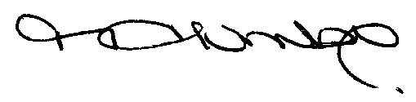
Mrs M. Humby
Clerk to the Council
30th October 2018

Members of the public are welcome to attend this public meeting as observers only. If anyone wishes to make a representation at the meeting concerning any item on the agenda, please contact the clerk at least 24 hours before the meeting to arrange this. Speaking will be restricted to a maximum of 5 minutes per person and the overall session will last no more than 15 minutes.

AGENDA

- Welcome from the Chairman including housekeeping notices and apologies
- To receive declarations of interest
- Public Session
To consider representations made by members of the public. Please see above for details of this.
- To confirm the minutes of the Policy and Finance meeting 18th June 2018
- To consider Capital and General Grant Applications
- To consider Reserves Balances
- To consider Budgets to date
- To consider Employment Issues-This item is confidential and therefore members of the press and public will be excluded.

